**ASSIGNMENT – 2**

**CSE-231 OPERATING SYSTEMS**

**REFRESHER MODULE**

**Total Marks: ~~25~~ 20**

**Instructions:**

1. Each question is of 5 marks.
2. All questions have to be attempted.
3. Submit .pdf on gc (details will be shared soon) using nomenclature as <RollNo>_Assn2.pdf
4. Last date of submission is 5 October.
5. a. Write a C program to create the following matrix. You may use double pointers along with library routines like malloc(), calloc() and realloc().

b. Allow the user to change the number of columns in each row. You may populate each cell by a random number between 1 and 10.

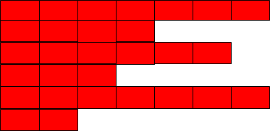

1. a. Write a C program to implement a singly linked list. The list should store student records i.e. -- name, rollno. , year of joining and enrolled academic program.

b. Reimplement (a) but with a doubly linked list.

c. Implement stack and queue using linked list.

1. Create an array of (void * -type) pointers of length 5. Each of these pointers should be pointing to individual functions that perform operations like addition, subtraction, division, multiplication, exponentiation.

|  |  |  |  |  |
| --- | --- | --- | --- | --- |

    

add(){ sub(){ mul(){ div(){ exp(){

} } } } }

These functions could take arguments just like regular functions.

1. ~~Write a C program such that there are the three following functions,~~ *~~viz. --~~* ~~A(), B() and C(). The function A() should at some point call function B(). However, you need to design B (i.e. manipulate its stack), so that B() doesn’t return back to A(). The return; operation from B() should invoke the execution of function C().~~

~~A(){ B(){ C(){~~

~~ //some operations //some operations //some operations  return;~~

~~B() return; }~~

}

}

1. [Bubble sort and selection sort] Write a program in C which has two functions bubble sort and selection sort. These functions both take an array as input, and depending on user’s choice given on the console input, the corresponding function is used.